Look up activity

1. Go to azure data factory
2. Go to pipeline
3. Go to general
4. Go to lookup drag and drop
5. In settings add dataset which is created for sql database
6. Now deselect first row only select table in use query

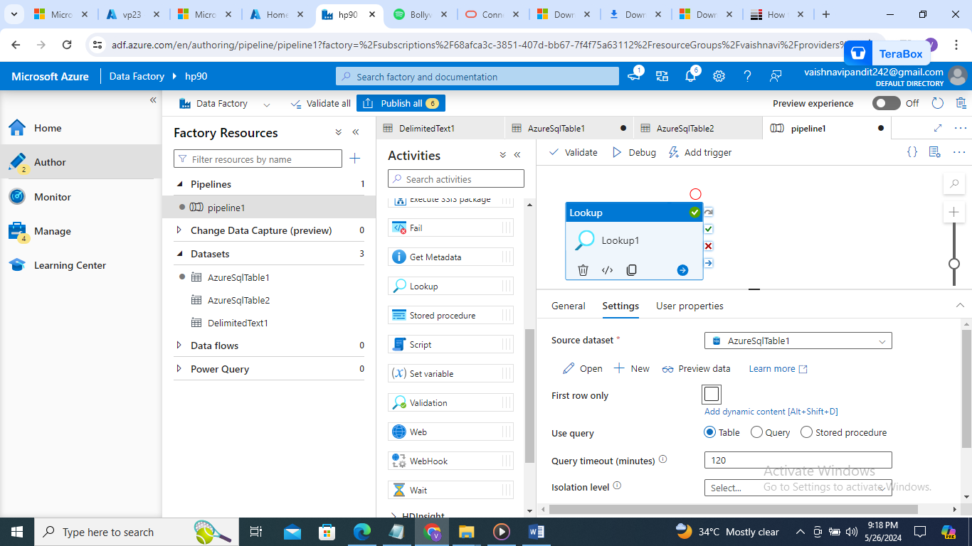

1. Output will be

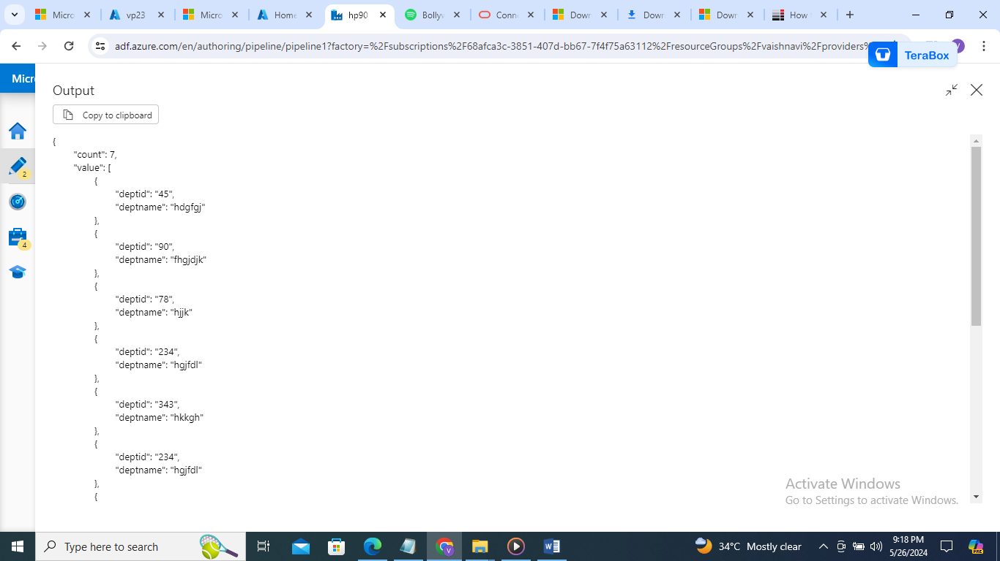

1. Now if you select query in use query

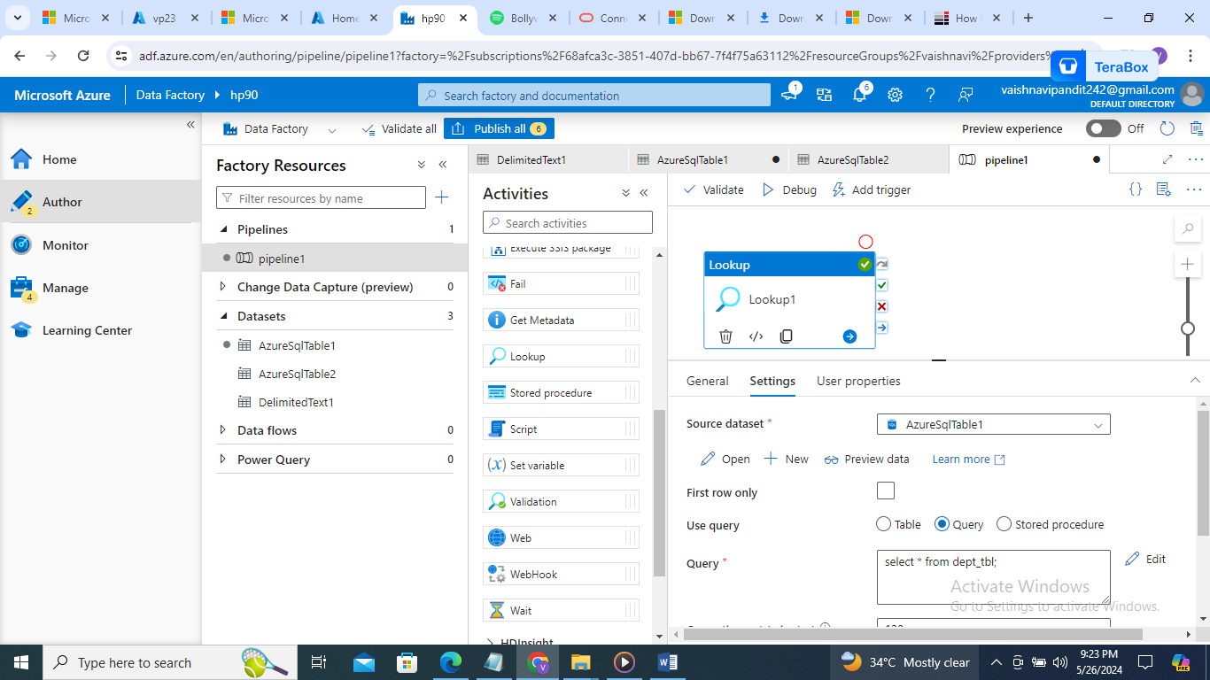

1. Output

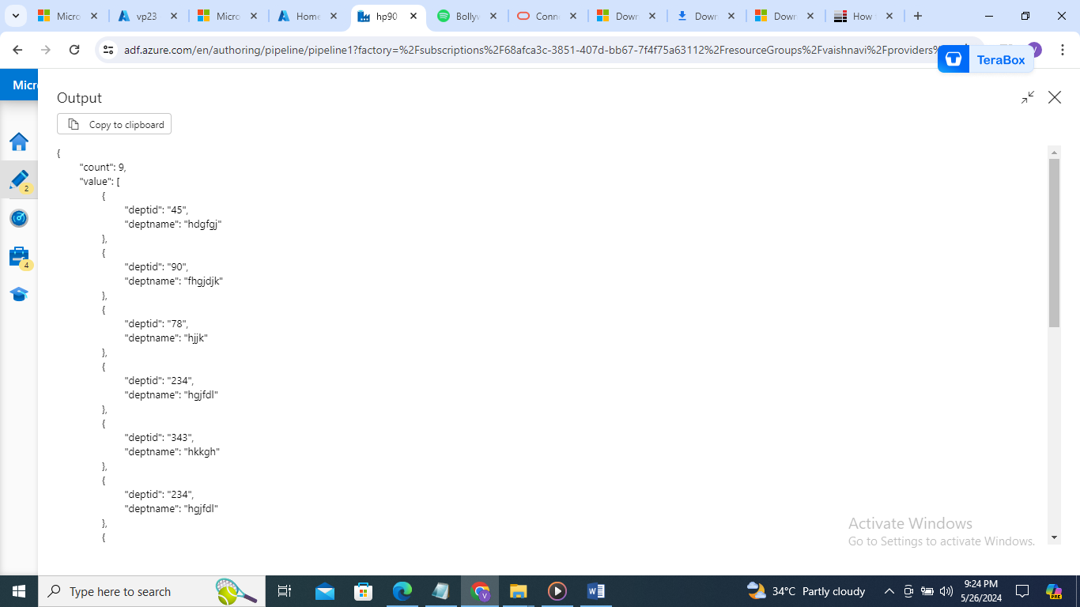

1. But we cant do insert query like that we need to drag script and write script there

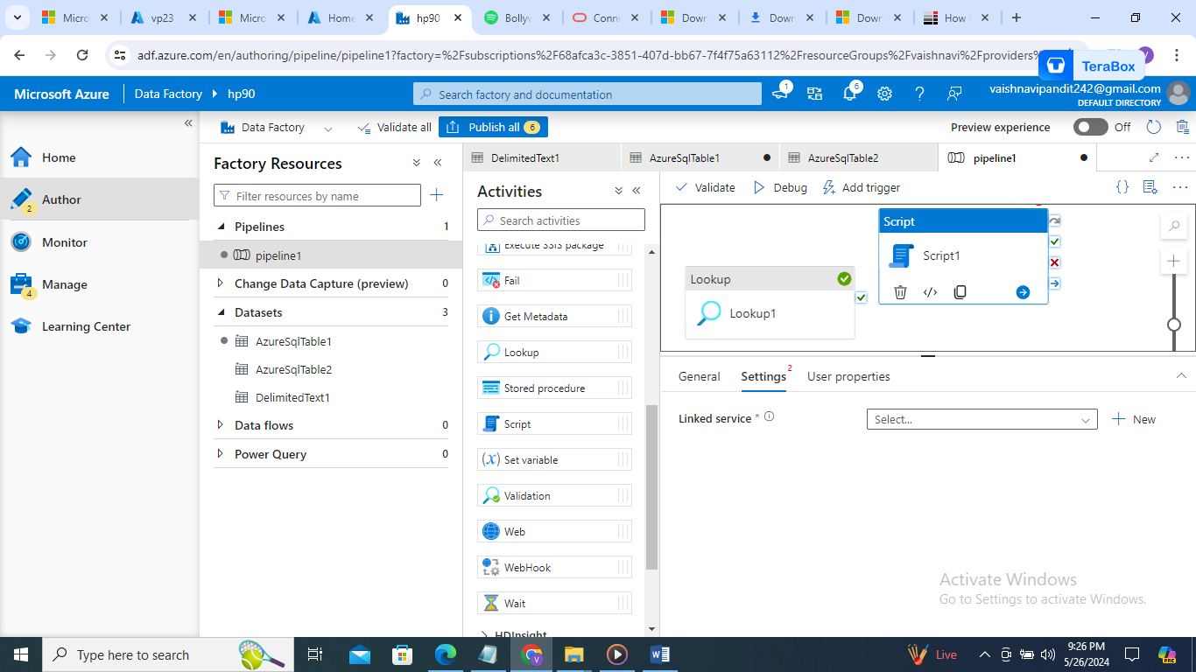

1. Select linked service linked to the database

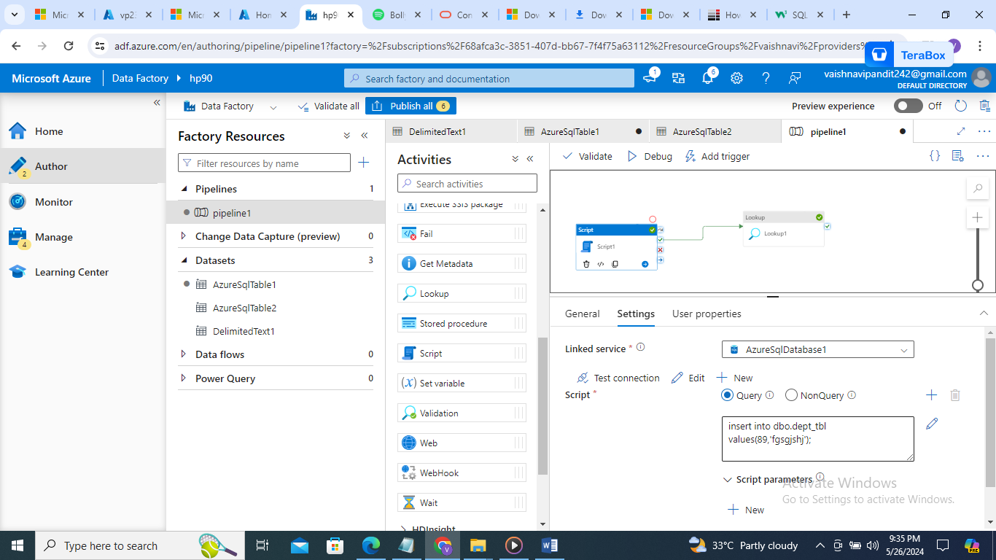

1. Now create look up activity to know if entry is available there

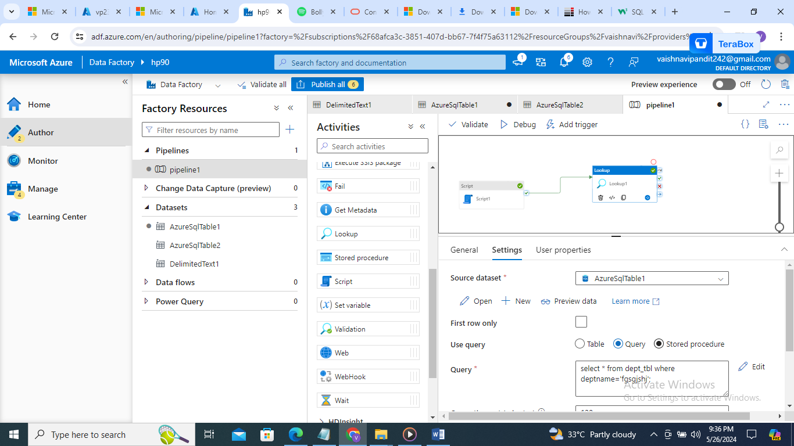

1. If you want to create procedure like parmeterized function to get data insert data
2. For that go to sql database write query

create procedure insertdata

@id varchar(20),

@name varchar(40)

as

begin

insert into dbo.dept_tbl values(@id,@name);

end

create procedure getdeptdata

@id varchar(20)

as

begin

select * from [dbo].[dept_tbl] where deptid=@id;

end

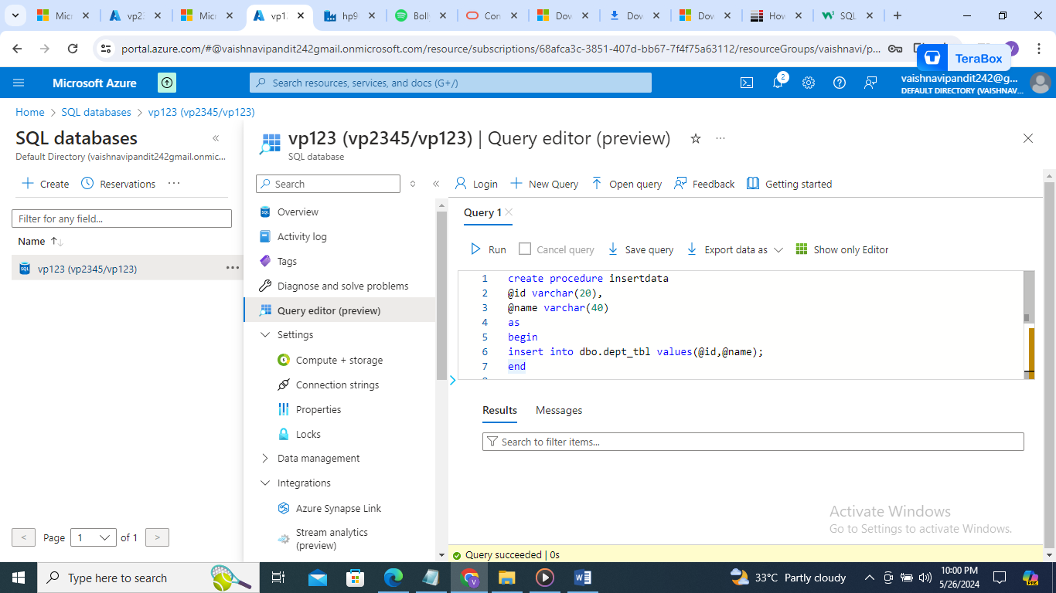

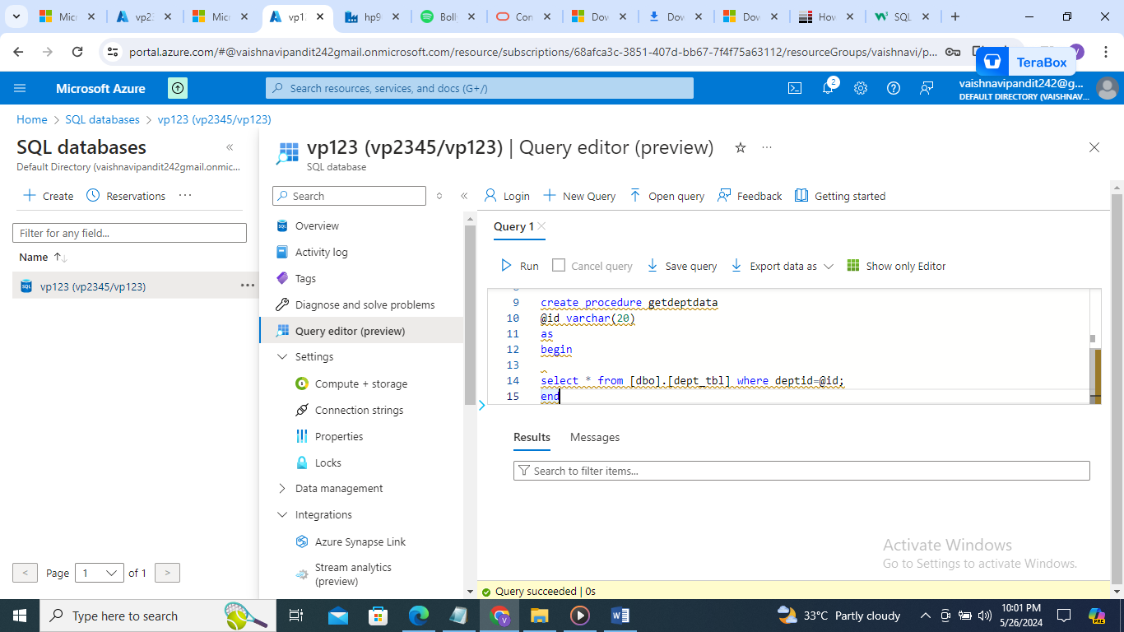

1. Now go the azure data factory look up activity
2. Select use query as stored procedure and in stored procedure name you will get name of procedures you created

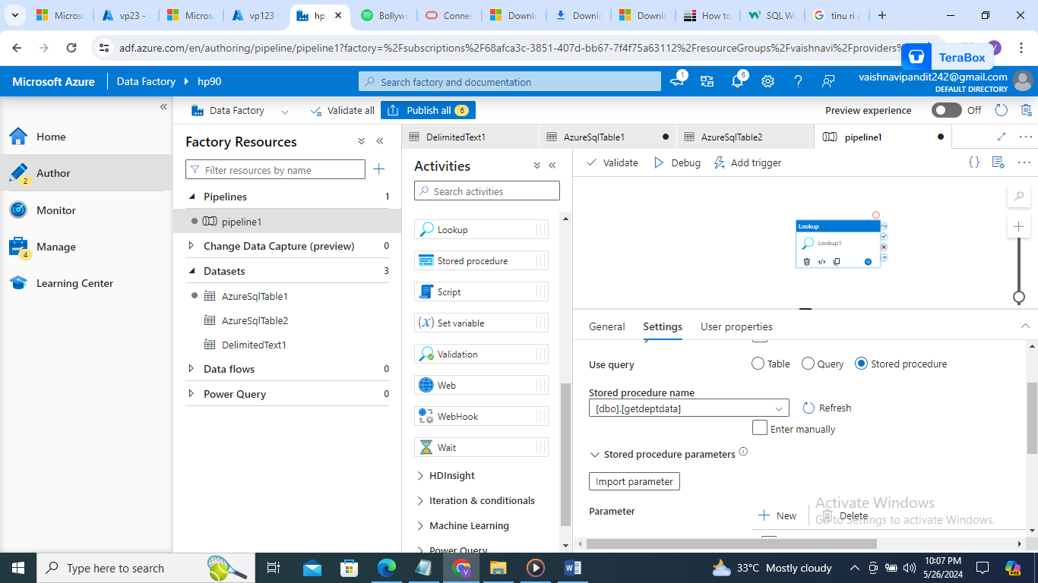

1. Now import parameter

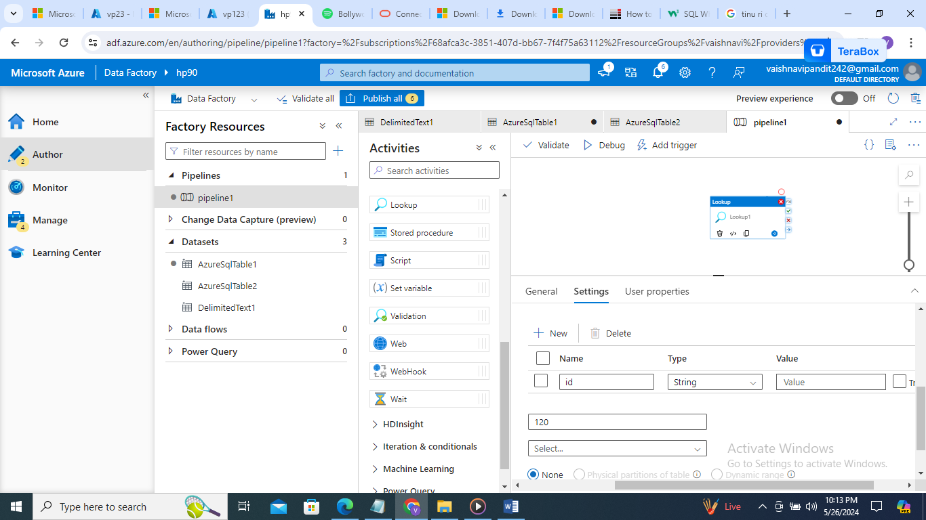

1. Output: it will fail but if you did it for insert the data will be inserted but activity is shown as failed activity
2. For stored procedure there is different store procedure
3. Go to general select stored procedure drag and drop
4. Then I settings select linked service

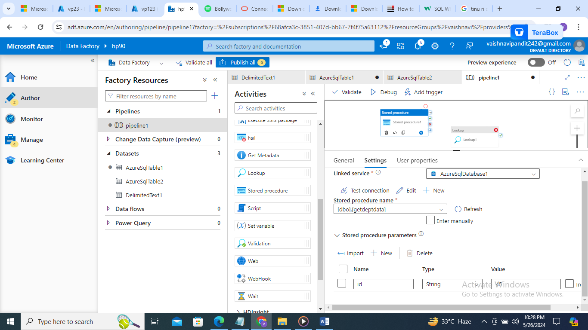

1. And keep lookup activity as it is

